Shabbos Stories For Parshas eikev 5784

Volume 15, Issue 52 20 Menachem Av 5784/August 24, 2024
Printed L’illuy nishmas Nechama bas R’ Noach, a”h
For a free subscription, please forward your request to keren18@juno.com
Past emails can be found on the website – ShabbosStories.com

Defining True Ahavas Yisroel
By Rabbi Sholom DovBer Avtzon

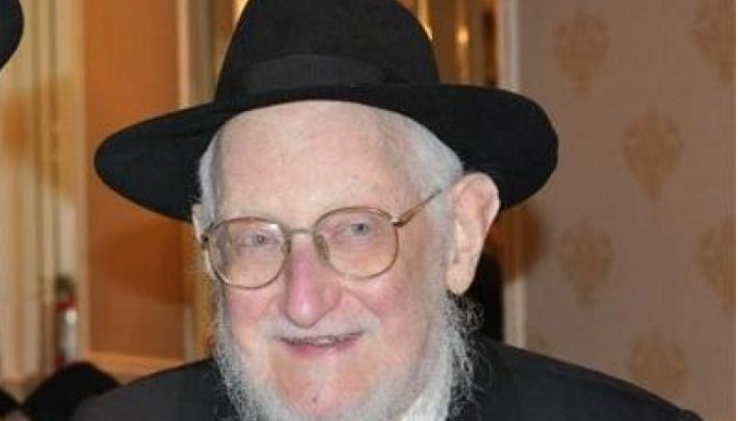
Rabbi Sholom DovBer Goldshmid of blessed memory

Rabbi Sholom DovBer Goldshmid was a bochur in 770 and he would seek the Rebbe’s guidance in many aspects of his life. This was especially so when he came to the stage of shidduchim, he turned to the Lubavitcher Rebbe for guidance. Being that in those years there weren’t that many chassidim, it was easy to have a yechidus (personal audience) with the Rebbe, and this was especially so for the students of the yeshiva in 770.
During one yechidus the Rebbe told him that Ahavas Yisroel is giving a Jew something they want, and this applies to every Jew, male or female.
At that point he had no idea what the Rebbe was referring to, but he knew that if the Rebbe mentioned it, it is an important aspect that he should act on it when he has that opportunity. To him it wasn’t a question of if, but of when he would be called on to fulfill that directive.
Sometime later, Rabbi Hodakov [the Rebbe’s personal secretary] called him into his office and said that he would like to propose a young lady to him. He then informed him of her name, adding that she is a niece of Rabbi Yosef Weinberg.

Getting Advice from the Lubavitcher Rebbe
They met, and after some time they both were ready to become engaged, but he informed her that although he is ready, he first would ask the Rebbe for his opinion.
The Rebbe replied that it is an appropriate match, and then added, that if you would want me to be mesader kiddushin(officiate at the wedding), as is known, that I will only do so if the bride will wear a wig after the marriage.
When he mentioned this to her, she replied that a wig is befitting old women; it is not for me! [It should be noted that very few Orthodox women wore wigs in the early fifties]. Although he didn't argue with her or say anything negative, she noticed an expression of unhappiness on his face. Rabbi Weinberg also noticed it, and without her noticing, he hinted to him that he will talk to her and try to convince her to put on a wig.

The Girl was Very Upset
However, she was strong in her opinion and didn't feel that it is necessary to wear a wig and restated her decision that she wouldn’t. Yet at the same time she believed that her uncle discussed it with her on behalf of her chosson, and being that he was so disappointed that because of her refusal, the Rebbe wouldn’t officiate at his wedding, he would break off the engagement. So, she poured out her heart out to her uncle and said that she would like to speak to her chosson.
Sholom Ber came to the house, and she said to him, “In Poland I lost both of my parents and I felt like a nobody, a shmatte (a rag). Finally, my uncle was able to contact me and took me into his house, and I was looking forward to the day that I would be independent and have my own dignity, and not be a burden to anyone. Now that you are disappointed that the Rebbe won't be mesader kiddushin, and the shidduch will be broken, I will lose my chance for my own dignity and will be a rag once again.
“Why are you saying that?” asked Reb Sholom Ber, “I am not thinking of breaking the engagement; I will marry you.”
She look at him in disbelief, unable to verbalize her thoughts; why will he marry me if I am letting him down by causing that his Rebbe will not officiate at his wedding?
Sensing her thoughts, he said, “I am not considering that because I am a student and a chossid of the Rebbe.” Seeing her total bewilderment, he said, “I once mentioned to you the guidance the Rebbe gave me personally - that Ahavas Yisroel is giving a Jewish man or woman what they need.

“We Will Get Married and You Will Have Your Dignity”
“You said that you need your dignity, and that would come to you when you will be married, and if I don’t marry you, you will be a shmatte. So, being that I am a student of the Rebbe, I will listen to his guidance and give you what you so dearly desire. We will get married, and you will have your dignity.
The girl was overwhelmed with gratitude and couldn't believe it. To make her happy, he is willing to forgo the biggest honor of his life of the Rebbe officiating at his wedding.
After a moment she said, and I also wish to be a student and follower of the Rebbe, in order to make you happy, I will gladly purchase a wig and wear it.

Reprinted from the Parshas Devorim 5784 email of The Weekly Story by Rabbi Sholom DovBer Avtzon.

The Orphan Girl and
The Kerestirer Rebbe

Rav Yoel Gold related a story. In the unstable days before World War II, 14-year-old Rochel Salgo’s father passed away. Rochel’s mother was unable to keep the family together, and she sent Rochel to Budapest to live with her late husband’s brother, Rav Yosef Salgo, and his wife. Rav Yosef was a Rosh Kollel, and a devoted Chasid of the Kerestirer Rebbe, Rav Meir Yosef Rubin.
The Salgos would collect money and send donations to the Kerestirer Rebbe, and once Rochel was old enough, she became the one who would bring the money to the Rebbe. Every month, she would go to the Budapest train station and make the 90-minute trip to Kerestir to deliver her uncle’s gift. Her visits were so regular that the Rebbe and his attendants eventually grew to expect them. They were impressed with the young girl from Budapest and her dedication to Tzedakah.
Meanwhile, the political situation in Europe grew more and more perilous by the day. War was imminent. And then, Rav Yosef Salgo passed away in Budapest. In a tribute to his devoted Chasid, the Kerestirer Rebbe and two Gabbaim made the trip north to Budapest for the Levayah. They were unsure of when they would be able to return, so they only purchased one-way tickets, so that they would not be bound to a specific train schedule.

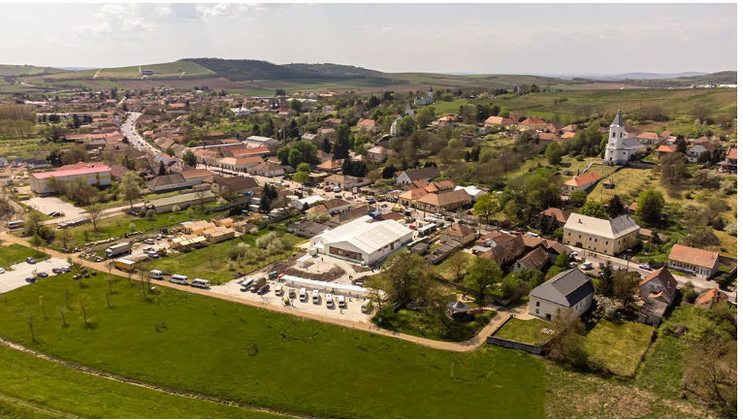
Tens of thousands of Jews visit each year the Kerestirer Rebbe’s grave

But from one minute to the next, the world dissolved into chaos. In the middle of the Levayah, Germany arrived in Budapest. Trapped, the Rebbe asked if anyone was willing to go to the train station and purchase return tickets to Kerestir, despite the soldiers spreading throughout the city, rounding up the Jews. Rochel volunteered to walk into the lion’s den. There were soldiers everywhere, and she could not see how she would be able to make it out alive.

All the Jews in the Train Station Had Been Captured
One Hungarian soldier approached her and asked, “Are you Jewish?” Unable to lie, Rochel nodded. He barked at her, “What are you doing here? Go home!” Somehow, Rochel removed herself from his presence. She ran to the other side of the station and purchased three tickets to Kerestir. But on her way out, the Nazi invasion reached the train station. Within a few moments, all the Jews in the station had been herded into a circle. They were surrounded. The clock was ticking, and at any moment, one of the soldiers could shoot her without explanation.
But then what would become of the Rebbe? Seeing a trustworthy-looking non-Jew, Rochel approached, handed him some money, and asked him to deliver the train tickets to a specific address. It was Hashgachah that she did so, for Rochel never went home again. That same day, she was deported to Auschwitz.

The Kerestirer Rebbe Was Able to Escape Hungary to Safety
Meanwhile, the Kerestirer Rebbe fled Budapest. He and his family escaped the country and made their way to safety in the United States. In her later years, Rochel Salgo, now Rochel Fleischmann [after having survived the Holocaust and making a new life in the United States], made Aliyah from America. After a tumultuous life, she moved to Eretz Yisroel to settle in peace, adopting a calm, unhurried routine.
She was always careful to finish all her preparations for Shabbos by 12 o’clock on Friday, and by 11 in the morning, she would be waiting calmly by the phone for her children to call from the United States to wish her a good Shabbos.
Almost seventy years after her deportation to Auschwitz, Rochel Fleischmann passed away early on a Friday morning in Yerushalayim. She was to be buried with her husband in Rechovot, an hour and a half away. Her children were in a race against the clock, afraid that the medical personnel would drag out the process to complete paperwork. But minutes later, the hospital inexplicably released the body. A high-ranking Knesset member had called to say that he would take responsibility for the legal implications. The family never found out who it was.

A Quickly Held Levayah Before Shabbos
They headed for the Bais HaChaim (cemetery) immediately. Clearly, someone wanted to repay Rochel’s devotion to Shabbos. The Levayah (funeral) was held in a rush, scheduled for Rochel Salgo as the young girl in Hungary. At 4:30 in the afternoon Israel time, two of Rochel’s children, Mayer Fleischmann and Leah Sara Miller, were stuck in America, watching the Levayah on live hookup at 9:30 A.M. With ten minutes to go before the Levayah would begin, Mayer’s Rav called and said that performing a Chesed Shel Emes for his mother from across the ocean might not be as simple as it seemed.
If he wanted to say Kaddish together with the mourners at the graveside, and of course he did, he needed to get a Minyan in his house. Mayer panicked. They were at the outskirts of Boro Park. There were three adult men in the house: Mayer, his son, and his brother-in-law. They had less than ten minutes to find seven more. Just then, Leah Sara remembered about the small Chasidishe Shtiebel that was on the corner. She asked her husband to run down the block and check if there was anyone still there.
Seconds later, he was running back up the block followed by five young men, all of whom were yelling rapidly into their cell phones for their friends to join them. By 9:27, they had a Minyan. With his brother onscreen, Mayer joined in saying Kaddish for his mother. When the Levayah had concluded, the Aveilim sat down to begin sitting Shivah, and the young men who had completed the Minyan became the first Menachamim.

The Connection with the Kerestirer Rebbe’s Offspring
It was only then that they realized the significance of what had just happened. Five of the men who had made it possible for them to say Kaddish were, in fact, the grandson and great-grandsons of the Kerestirer Rebbe himself. Rochel Fleischmann had risked her life to send the Rebbe and his family to safety, and his family had given her an escort on her final journey!

Reprinted from the Parshas Devorim 5784 email of Rabbi Yehuda Winzelberg’s Torah U’Tefilah.

The Legendary Rabbi
Yehuda Aryeh of Modena
By Rabbi David Bibi

There was once a gaon, philosopher and kabbalist, Rebbi Yehudah Aryeh of Modena z”l (1571-1648) who has a book called “Ari Nohem” and responsa. This gaon was graced by Hashem with a great talent for learning, his was literally a fulfilment of the passuk, “the words of his palate are sweet and he is all delight” [Shir HaShirim 5:16]. He lived in Venice and during his time there was a huge bet knesset in the city which could seat a thousand men.
One day the gabbaim of the bet knesset came to the rav and asked him that since they don’t have a rav who can give derashot that he come on Shabbat to the bet knesset and give them a derashah before Musaph. The rav replied that since the bet knesset was far from his home and he was getting old he was unable to come and give them a derashah. The gabbaim greatly pressured him to heed to their request to come just for one Shabbat. Until the rav was unable to withstand their pressures and he ceded to their request to come and give them a derashah.
On Shabbat Kodesh before Musaph the rav was honored to stand before the whole kehillah and he gave a derashah for a full hour about the Parashah of the week. The rav darshened and his mouth spoke pearls and gems! The congregation made their ears receptive to hear his sweet words and they very much enjoyed it. They were literally unaware that a whole hour had passed!

A Token of Their Appreciation – a Gold Watch
On Sunday the gabbaim came to the rav’s home. They said to him, “Kavod harav we have brought you something, not chas veshalom as a payment, for it is impossible to paid his honor for the words more precious than gold and fine gold, just a token due to ‘appreciation’, we brought his honor a gold watch!” The rav saw and accepted the watch.
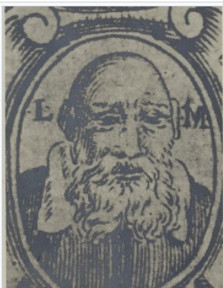
A woodcut illustration of Rebbi
Yehudah Aryeh of Modena

The gabbaim said to him, “Kavod harav, his honor saw how much the congregation benefitted from his words on Shabbat, do us a favor for Hashem’s sake and darshen before us also this coming Shabbat, this is a matter of meriting the many!”
The rav responded, “I cannot! It is difficult for me to make the journey to you on Shabbat!”
The gabbaim said to him, “How hard is it? Since this Shabbat his honor already came to us, if so, just like on one Shabbat his honor was able to walk, so shall he do also on this coming Shabbat!”
The rav answered them, “Fine, I will come also this Shabbat! One Shabbat and that will be enough!”
The rav was further honored to darshan and the bet knesset was packed from wall to wall and all the congregation were listening most intently to every word that came out of his mouth, “words that come out of the heart enter the heart!” [The source of this adage is Rav Moshe ibn Ezra z”l 1055-1140 in his Shirat Yisrael.] A whole hour did the rav speak and then he returned home.

The Gabbaim Again Brought the Rav a Token Gift
On the next day, Sunday, again the gabbaim arrived at the rav’s home, they said to him, “Kavod harav the payment which his honor is entitled to has no bounds, but we have just brought a token gift, they produced an expensive chandelier and presented it to the rav.” Immediately afterwards they again pressured the rav that he come again on the next Shabbat to the bet knesset to darshan for a third time since “a three-ply cord Is not easily severed” [see Kohelet 4:12] and the rav’s words in a further derashah will certainly make a tremendous impression!
The rav agreed and again arrived in the bet knesset , but this Shabbat the rav’s derashah was extraordinary, above anything that the kehillah had heard. The derashah was full of words of wisdom which were pleasant for the ear to hear and the congregation rejoiced in it in an exceptional way.

A Third Unique Gift – An Etrog Box of Pure Silver
Again, on Sunday the gabbaim went up to the rav’s home and presented him with a unique gift, an etrog box of pure silver! And as they were accustomed to, they again pressured the rav that he continue to give derashot in their bet knesset. The rav answered, “Enough! I already told you that I will darshan a third time because ‘a three-ply cord Is not easily severed’, and is now required ‘a four-ply cord’? What do you want from me?” They pressured and pressured, and attempted to convince the rav that he present on a permanent basis in the bet knesset.
Eventually the rav conceded, but he said to them, “I have a condition! Before I become the permanent darshan in your holy camp, take with you all the gifts which you gave me, the watch, the chandelier, the etrog box, take everything with you! Only then will I agree to darshan!”
The gabbaim were astonished. “What’s the connection? Why is the rav not prepared to accept the gifts?” The rav replied to them, “I will respond with a parable. A person entered a watch shop. He was interested in a unique expensive gold watch, he paid the full price and immediately in front of the seller he took the watch and threw it on the floor smashing it at his feet! The shop keeper won’t be angry with such a person, since he paid for the watch, on the contrary perhaps now he will buy another watch!
“In contrast a chatan stood under the chuppah and one of his loved ones came to him and in their hand was a gold watch which they purchased as a gift with their money. Suddenly the chatan took the watch and threw it to the ground and smashed it at his feet! Surely such behaviour will offend the giver! How dare the chatan despised his precious gift! This is so offensive!

Reprinted from the Parashat Debarim 5784 email of Rabbi David Bibi’s Shabbat Shalom from Cyberspace.
Red Light
By Rabbi Yosef Weiss


Lakewood Police Detective Bill Addison (now retired)

The customs and obligations of Purim create a festive and exciting atmosphere. But there’s one side effect to all this activity – the unceasing traffic that fills the streets. As a precaution to this potentially dangerous situation, community activists convene with the local police to detail security and traffic restrictions. Strict measures must be taken to ensure that safe driving and safe streets will safeguard the happiness of the day.
The day before Purim in Lakewood, R’ Menashe Miller was scheduled to meet with Sergeant Bill Addison, Badge #31, to review the day’s itinerary. Five minutes before the police officer was due to arrive, he called R’ Menashe from his cell phone.
“I’m sorry, Rabbi, but I’m going to be a little late. A lady just blew a red light right in front of me. It’ll probably take about twenty minutes – I’m going to pull her over and issue a summons.”
Sergeant Addison disconnected the call and strode importantly over to the driver’s window. She had pulled over to the side and stopped.
“License and registrations, please.”
The woman inside handed over the requested items without a word. Sergeant Addison examined the documents, then raised his eyes to the driver. “Ma’am, do you know what you did wrong?”

She Confessed that She Hadn’t Noticed the Light Turn Red
“Yes, sir,” she said meekly. “I didn’t concentrate on my driving.”
“Do you have anything to say in your defense?”
The woman turned away from the officer to look at her five-year-old, who was seated snugly in the back seat, quietly absorbing the scene. Sergeant Addison also noticed a baby strapped into the back, and a bottle clutched in the woman’s hand. She must have been trying to give the baby the bottle, he surmised, and she didn’t notice that the light had turned red. The woman turned back to him. “No, sir, I don’t.”
Sergeant Addison was surprised. She hadn’t even explained about the bottle.
“You know, ma’am, most drivers try to justify their traffic violation. Was there a reason why you ran that red light? Were you in a hurry to get somewhere? Were you in the middle of doing something?” His eyes strayed to the baby bottle in her hand.
To the puzzlement of Sergeant Addison, the woman turned to meet her son’s inquisitive eyes before answering the question. “No, sir. I was wrong. It was the wrong thing to do.”

“Why Aren’t You Trying to Excuse Yourself?”
“Ma’am, everyone says something,” he said in exasperation. “You can’t just take the ticket without trying to excuse yourself.”
The woman gave the child one last meaningful glance, and answered with quiet conviction. “My five-year-old is listening to every word I say. If I start making up excuses, what kind of lesson would I be teaching my son?”
Five minutes later there was a knock at Menashe Miller’s door.
“Sergeant Addison!?” R’ Menashe asked. “How did you get here so quickly?”
“Wait till you hear this one, Rabbi,” the sergeant responded, still shaking his head in bemusement.
R’ Menashe listened as Sergeant Addison recounted the incident. “I was so impressed, I didn’t give her the ticket,” the officer concluded, “And here I am.”
Sergeant Addison took the seat offered to him, and got down to business. People like that certainly deserved the best safety precautions on their joyous holiday. (Excerpted from “Visions of Greatness VIII”)

Reprinted from the Parashat Debarim 5784 email of Rabbi David Bibi’s Shabbat Shalom from Cyberspace.

A Special Request to Abaya
By R’ Yoni Schwartz

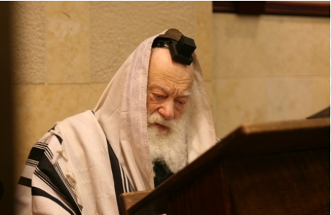
Rav Shmuel Berenbaum of blessed memory

Rav Shmuel Berenbaum, ZT”L, the Rosh Yeshiva of Mir in Brooklyn was once approached by a desperate talmid. “My wife has stage-four cancer. Please do something, give her a bracha, a guarantee that she will survive.”
Rav Berenbaum, explained with great sorrow, that it is beyond his power. The talmid persisted, “Please! You are our Rosh Yeshivah; you must do something.”
The Rav agreed and sent him off with a bracha. Shortly after, the talmid received a call from Berlin, Germany. There was an experimental treatment being tested and his wife was one out of the twenty people worldwide to be selected to receive it. With nothing left to lose, they headed to Berlin. Out of those twenty people, only two of them were cured and she was one of them.
After experiencing nothing short of a miracle, the couple came to Rav Berenbaum with the joyous news and asked what he did because, clearly, it worked. Rav Berenbaum explained: “After you left that day, I sat in front of the Gemara learning an intense debate between Abaye and Rava, the Sages of the Gemara. I said, ‘Abaye, I talk to you. You are a friend of mine. Every day, we learn together. This man also learns from you each day and if something happens to his wife, who is critically ill, he will be unable to continue talking to you all day. Please, go to G-d’s Throne of Glory and pray to Him on our behalf.’”
The Rav then turned to the couple and said, “It seems Abaye did his job well.”

Reprinted from the Parshas Devorim 5784 email of Torah Sweets.

The Saraf’s Tendency for Screaming When Davening

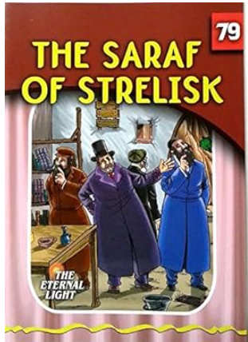

A traveling merchant was once on the road when Shabbos was nearing. He suddenly found himself caught in a dilemma; where he should spend Shabbos? After inquiring of the locals, he was told to go to the house of the Saraf of Strelisk. He was known as the place to spend Shabbos. His wife was a well-known machneses orech, and the Saraf was known for his bren in mitzvos. Every part of Shabbos was done with bren and enthusiasm.
The merchant approached the wife of the Saraf and asked if he could spend Shabbos with them, and she happily welcomed him into the house. She set up comfortable quarters for him to stay and prepared for him a welcoming delicious snack. After the Friday night seudah, she turned to the merchant and asked if all the accommodations were suitable.
He confirmed that everything was well and fine, “But there one thing that bothers me!”
“What’s bothering you?” she asked in surprise.
“Is there anything I can help you with?”

The Guest Doesn’t Scream When He Davens to Hashem
“Why does the Saraf scream when he davens? I also daven, yet when I do it, I don’t scream. Hashem hears and listens to me, even when I talk normally.”
“The Rebbe does that out of his excitement of talking to Hashem,” the rebbetzin replied.
But the merchant didn’t accept her answer. “I also daven with passion, and yet I don’t scream. Why does the Rebbe have to scream when he davens?”
The Saraf’s wife tried explaining a few times, but whatever she said fell on deaf ears. After the Shabbos day seudah, again the Saraf’s wife asked their guest how he was doing. And again, the guest responded that while everything was fine, he still couldn’t get over the Rebbe’s screaming during davening. “I’m going zany over the loud noise!”
His wife went on to explain again how her husband’s davening was coming from his spirit, and that there was nothing to do in order to prevent it. As the sun of Motzaei Shabbos set under, the guest inhaled a sigh of relief. He would no longer hear the screaming voice of the Saraf echoing in his ears anymore. He would be able to take his belongings and set off to the marketplace.

The Wife Denied Ever Receiving the Guest’s Wallet
Before he left, he went back to retrieve his wallet of his savings that he’d given to the Saraf’s wife to watch over Shabbos. When he requested that she return the bag, she denied having every received it.
“When Shabbos was approaching,” he reminded her, “I handed you my personal belongings to protect over Shabbos. You happily agreed then, and now you’re denying it?”
“What belongings? she unassumingly replied. “You didn’t give me anything to watch!”
Raising his voice, he replied, “Before Shabbos, I gave you all my savings!” Seeing the ignorance in her eyes he raised his voice louder. “That was all money that I’d been saving for many years to finally take to the marketplace. I need that money to sustain my wife and kids, and now you’re robbing it from me! What cruelty!”
The Saraf’s wife went to explain, “You see for yourself, that when something affects you deeply you also get emotional. When something is of value, you don’t remain calm, you get worked up. It’s just a matter of what affects you. To my husband it’s a davening, and to you it’s your money.”
The Saraf’s wife calmly went to get the merchant’s money, but before she handed him the money, she sat him down and told him a story.



“Many years ago, late at night, my husband returned from learning and something seemingly moved him. After questioning him, he explained that he saw a goy take a torch and engrave a ‘cross’ in the lake. The lake had frozen over, and he took a torch to engrave what he wanted.
“Shocked at his response, I turned to my husband and asked, ‘What does it matter to you what the goy is doing? In the past you’ve never related to anything they do, so what happened now that caught your attention?’
“I’ll explain,” the Saraf said. “Had the lake not been frozen, there wouldn’t be anything to melt. He therefore wouldn’t be able to melt it; the negative imprint would fall on nothing. Now that it’s cold and the water is frozen, the cross can be engraved, and its negative effects are long-lasting.
“This taught me a profound lesson in avodas Hashem. When serving Hashem is done cold, then it’s much easier to have bad things engraved, but when it’s done with warmth and bren, you can’t place such things on it.
“This is the reason why bren in avodas Hashem is important. When it’s done with bren, there’s no room for distant influences. It’s when that is missing, then it turns into a problem.”
With that, she returned the withheld wallet, and she got her point across. (L’romeim p. 19)

Reprinted from the Parshas Pinchas 5784 email of Zichru Toras Moshe.

